**TITLE PAGE**

**DATA SCIENCE PROJECT**

**SUBMITTED BY: SANIKA CHIDDARWAR**

**REG. NO.: 12316239**

**SUBMITTED TO: MS. BALWINDER KAUR**

**SUBJECT: DATA SCIENCE TOOLBOX (PYTHON PROGRAMMING)**

**SUBJECT CODE: INT375**

**IN PARTIAL FULFILMENT FOR REQUIREMENTS OF THE AWARD OF THE DEGREE OF**

**COMPUTER SCIENCE AND ENGINEERING**



**CERTIFICATE**

This is to certify that SANIKA CHIDDARWAR bearing Registration no. 12316239 has completed INT375 project titled, **“SKILL BASED ASSIGNMENT”** under my guidance and supervision. To the best of my knowledge, the present work is the result of his/her original development, effort and study.

**Signature and Name of the Supervisor**

**Designation of the Supervisor**

**School of Computer Science**

Lovely Professional University

Phagwara, Punjab.

Date:

**DECLARATION**

I, Sanika Chiddarwar, student of Data Science under CSE/IT Discipline at, Lovely Professional University, Punjab, hereby declare that all the information furnished in this project report is based on my own intensive work and is genuine.

Date: 10-04-2025

Signature   
SANIKA

Registration No. 12316718

Name of the student : Sanika Chiddarwar

**ACKNOWLEDGEMENT**

I would like to express my heartfelt gratitude to everyone who played a significant role in the successful completion of this data science project. First and foremost, I am deeply thankful to my mentors and academic guides whose constant encouragement, expert insights, and constructive feedback have been instrumental in shaping this project. Their guidance helped me navigate challenges and approach problems with a clear analytical perspective. I would also like to acknowledge the Government of India and various open data initiatives for providing access to rich and reliable datasets, without which this analysis would not have been possible. The availability of such data enabled a deeper understanding of the educational landscape in India and empowered this research with real-world relevance. I am equally grateful to my peers for the stimulating discussions and collaborative spirit, which enriched my learning experience. Finally, I extend my sincere appreciation to my family and friends, whose unwavering support, patience, and motivation provided the foundation I needed to stay focused and committed throughout this journey. This project has not only enhanced my technical skills but also deepened my awareness of the educational challenges and opportunities in India, and I am truly thankful for the opportunity to contribute to such a meaningful topic.

**TABLE OF CONTENT**

1. Introduction
2. Problem Statement
3. Objective
4. Source Of The Dataset
5. Code:
6. EDA
7. Objective one
8. Objective two
9. Objective three
10. Objective four
11. Objective five
12. Conclusion
13. Future Scope
14. References

**INTRODUCTION**

Education is the cornerstone of a nation's progress, and ensuring that students have access to quality infrastructure is fundamental to their academic and personal development. In a country as vast and diverse as India, schools operate under various management types—government, private, and aided—and are spread across urban and rural areas with varying levels of access to basic facilities. Infrastructure elements such as electricity, drinking water, functional toilets, clean classrooms, computers, and internet connectivity directly influence the learning environment and the effectiveness of the education system. While several national programs have been implemented to improve these conditions, disparities still persist across different regions and types of schools. This data science project aims to conduct a comprehensive analysis of the availability and distribution of essential infrastructure and facilities in Indian schools, focusing on key aspects such as management type, state-wise performance, digital readiness, gender-based access, and rural-urban gaps. By leveraging data, this study seeks to uncover critical insights that can support data-driven decision-making in the education sector.

**PROBLEM STATEMENT:**

Analyze the availability of basic infrastructure and facilities in schools across different state and management types in INDIA.

**OBJECTIVE:**

1. **Evaluating Basic Facility Access in Schools Across India** Analyze the overall availability of key infrastructure facilities such as electricity, drinking water, computers, libraries, and playgrounds. This helps assess the baseline quality of school environments across the country. The goal is to understand which facilities are most or least accessible to students.
2. **Infrastructure Availability by School Management Type** Compare how infrastructure availability differs across schools managed by different authorities like government departments, private organizations, and aided institutions. This comparison helps reveal systemic strengths or gaps in resource allocation among various school management types.
3. **Infrastructure Availability by School Category:** Analyze infrastructure availability across different school categories such as Primary, Upper Primary, and Secondary schools. This helps in understanding how infrastructure development progresses with educational level and identifies any underdeveloped stages in the schooling system.
4. **Distribution of Fully Equipped vs Under-equipped Schools** Classify schools based on whether they have all essential infrastructure facilities available or are lacking one or more. The goal is to identify how many schools meet complete infrastructure standards and how widespread under-equipped schools are across the dataset.
5. **Infrastructure Analysis in Rural** Areas Compare the availability of key facilities like drinking water, electricity, toilets, furniture, and handwashing across rural and urban schools. This helps uncover rural-urban disparities in school infrastructure and supports targeted improvements in underserved regions.

**SOURCE OF THE DATASET:**

<https://dashboard.udiseplus.gov.in/udiseplus-archive/#/reportDashboard/sReport>

NAME OF THE DATASET: Number of Schools by Availability of Infrastructure and Facilities, School Management and School Category

**EDA:**

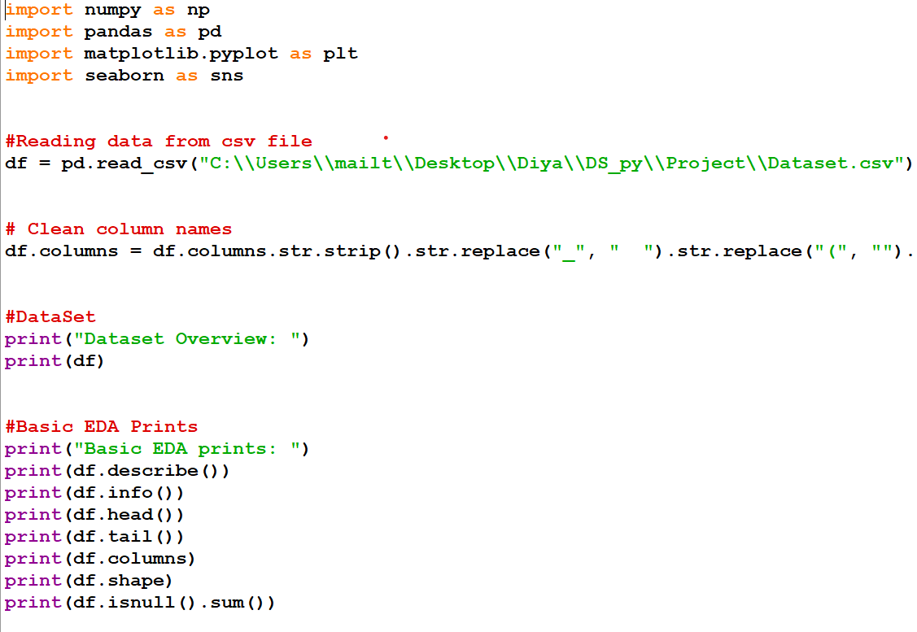

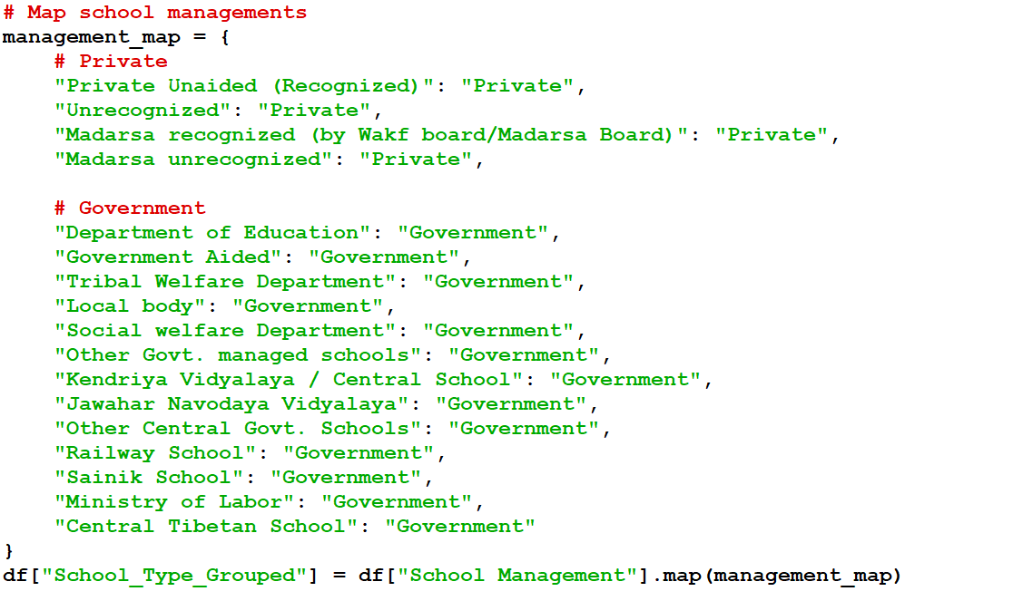

**OBJECTIVES:**

OBJECTIVE ONE:

**Evaluating Basic Facility Access in Schools Across India** Analyze the overall availability of key infrastructure facilities such as electricity, drinking water, computers, libraries, and playgrounds. This helps assess the baseline quality of school environments across the country. The goal is to understand which facilities are most or least accessible to students.

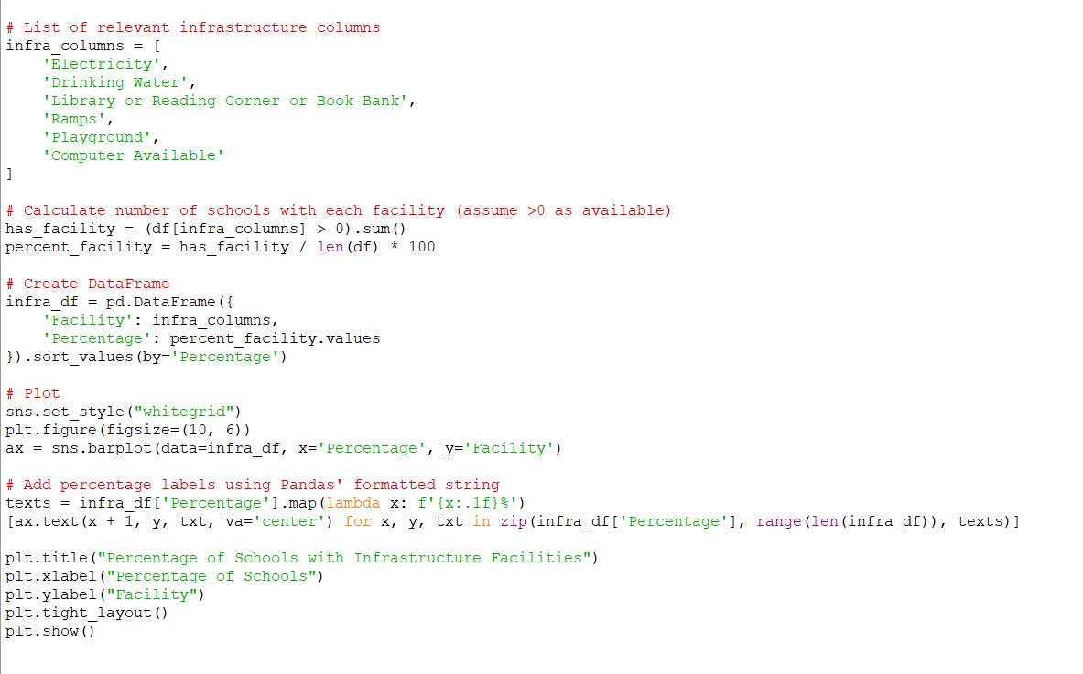

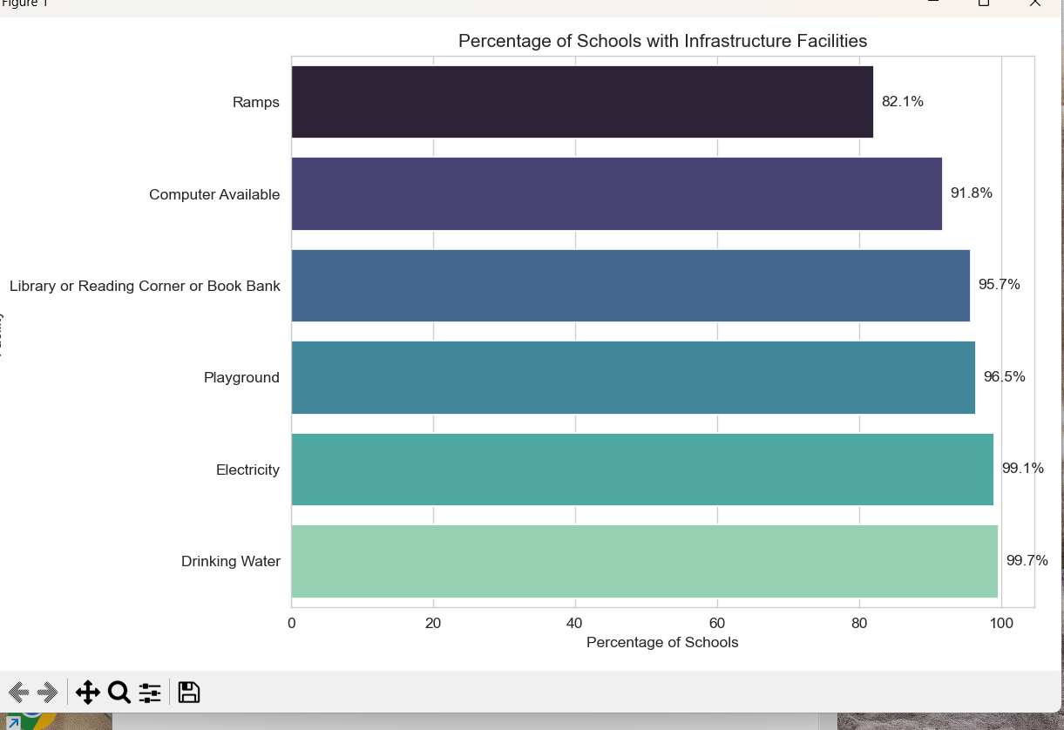

OBJECTIVE TWO:

**Infrastructure Availability by School Management Type** Compare how infrastructure availability differs across schools managed by different authorities like government departments, private organizations, and aided institutions. This comparison helps reveal systemic strengths or gaps in resource allocation among various school management types.

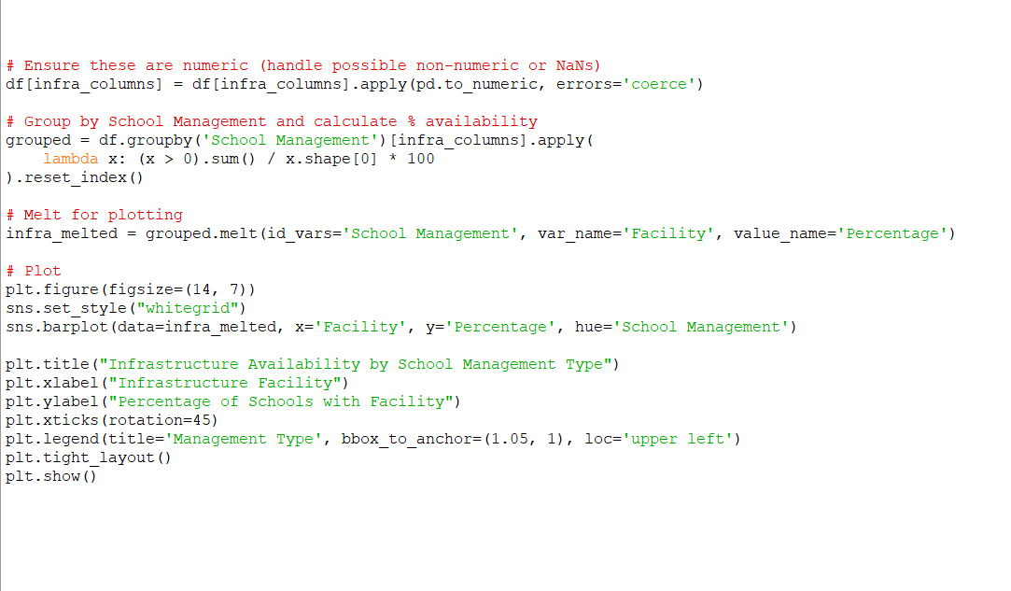

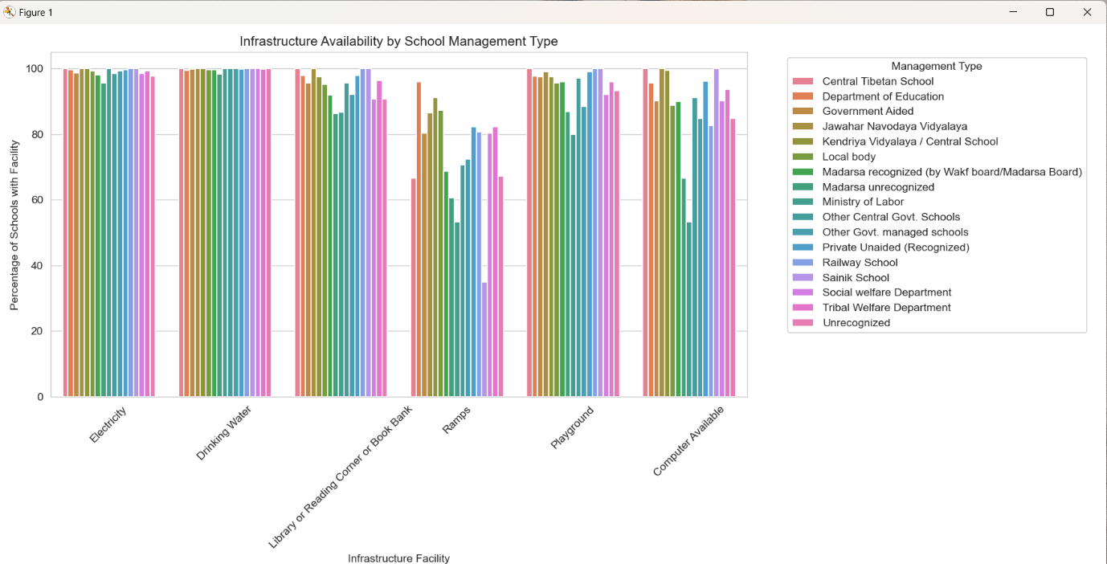

OBJECTIVE THREE:

**Infrastructure Availability by School Category:** Analyze infrastructure availability across different school categories such as Primary, Upper Primary, and Secondary schools. This helps in understanding how infrastructure development progresses with educational level and identifies any underdeveloped stages in the schooling system.

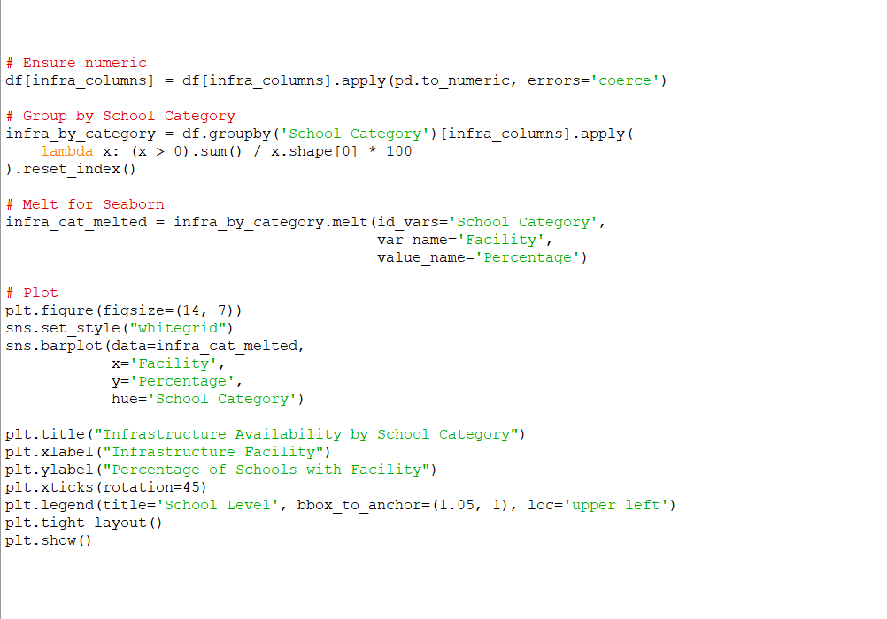

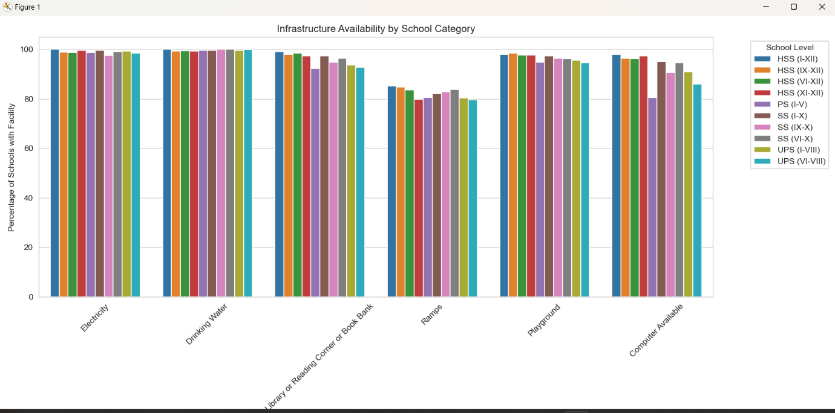

OBJECTIVE FOUR:

**Distribution of Fully Equipped vs Under-equipped Schools** Classify schools based on whether they have all essential infrastructure facilities available or are lacking one or more. The goal is to identify how many schools meet complete infrastructure standards and how widespread under-equipped schools are across the dataset.

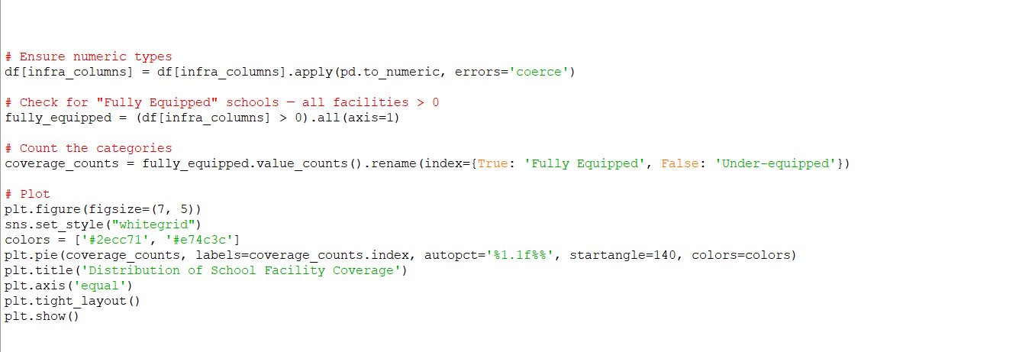

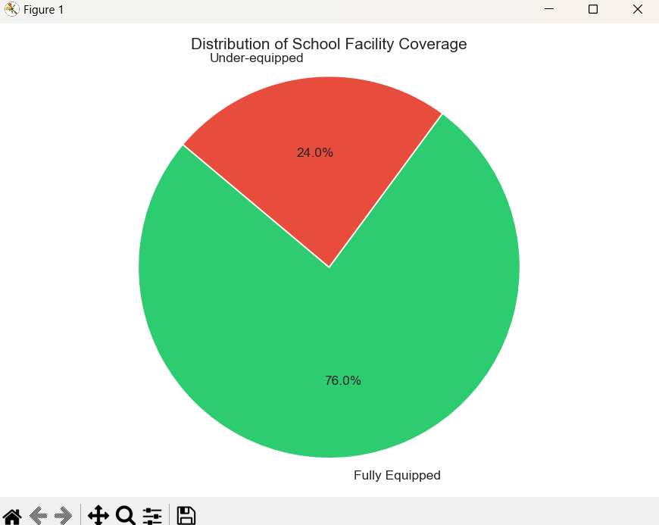

OBJECTIVE FIVE:

**Infrastructure Analysis in Rural** Areas Compare the availability of key facilities like drinking water, electricity, toilets, furniture, and handwashing across rural and urban schools. This helps uncover rural-urban disparities in school infrastructure and supports targeted improvements in underserved regions.

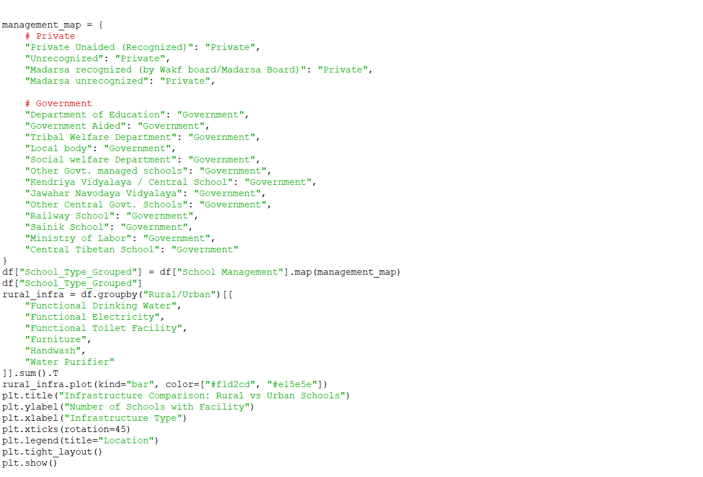

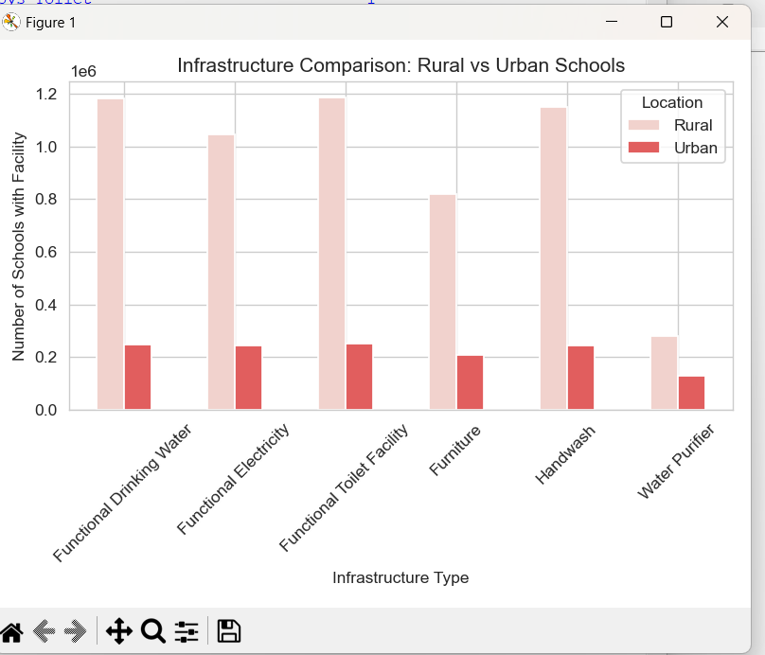

**CONCLUSION:**

This project provided a comprehensive analysis of the availability and distribution of basic infrastructure and facilities in Indian schools across different states and management types. The findings highlight significant disparities in access to essential amenities such as electricity, drinking water, functional toilets, digital tools, and internet connectivity—especially between government and private schools, and between rural and urban regions. Additionally, the analysis revealed patterns related to gender-based school types and underscored the urgent need to bridge infrastructure gaps to create an equitable and inclusive learning environment. By leveraging data science techniques, this study not only sheds light on the current state of educational infrastructure but also emphasizes the importance of targeted policy interventions and resource allocation. With data-driven insights, stakeholders can work towards ensuring that every child, regardless of their location or school type, has access to a safe, supportive, and technology-enabled education environment.

**FUTURE SCOPE:**

The future scope of this project includes several potential avenues for further research and development. First, the analysis could be expanded to incorporate more granular data at the district or block level, offering deeper insights into regional disparities in school infrastructure. Future studies could also focus on exploring the long-term impact of educational technology and internet access on student performance, particularly in rural areas and government schools. Additionally, a longitudinal analysis could be conducted to track improvements in infrastructure over time, assessing the effectiveness of various government schemes and policies aimed at enhancing school facilities. Another area for future research would be to explore the relationship between infrastructure quality and other educational outcomes such as dropout rates, student performance, and teacher quality. Lastly, advanced machine learning techniques could be applied to predict infrastructure needs in the future, allowing for more informed and proactive policy decisions. These advancements could significantly enhance the ability to bridge existing gaps and improve educational quality across India.

**REFERENCES:**

1. <https://www.w3schools.com/python/numpy/numpy_random_seaborn.asp>
2. <https://www.w3schools.com/python/pandas/default.asp>
3. <https://www.w3schools.com/python/numpy/numpy_intro.asp>
4. <https://www.w3schools.com/python/matplotlib_intro.asp>
5. <https://chatgpt.com/>?
6. Data science from scratch first principles with python
7. Numpy, Pandas, Matplotlib, Seaborn Notes

Linkdin link: <https://www.linkedin.com/feed/>

Github link : <https://github.com/sanikachiddarwar/python-project/new/main>